- interview
A: Hi, I’m Haly, our top football player today is Joe Brown, hello Joe, you did very well today, congratulation.
B: Thank you.
A: Which football team are you from?
B: I’m from Newtown school football team.
A: How old are you?
B: I’m eleven years old.
A: what’s your favorite sport?
B: You know, I play basketball and football, but my favorite sport is football, I play it very well.
A: when do you play?
B: I often play after school.
A: Where do you play? At school?
B: Yes, I usually play on the school playground.
A: How often do you play?
B: I play football four times a week.
A: That’s a lot! Who do you play with?
B:I play with my friend Jack, we are all on our school team.
A: who is your favorite player?
B: Well, my favorite player is Beckham, he’s so cool and plays very well.
A: Thanks.

- Do a survey(调查朋友最喜欢的运动)
Helpful sentences
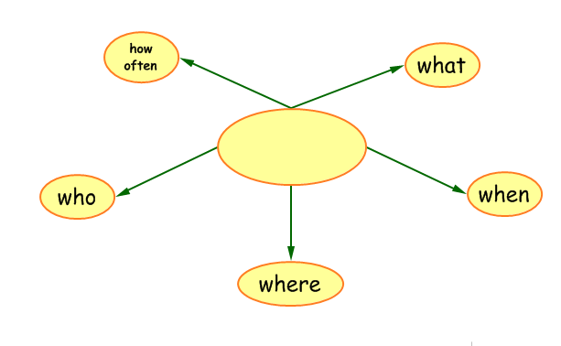
What’s your favorite sport?
When do you play?
Where do you play?
Who do you play with?
How often do you play?

Report: My friend is …, he/she…

三、reading

My name is Guo Jia, I am 11years old, I am from grade five. My favorite game is table tennis, I like it very much and I am a player on our school team, I play everyday with my friends after school. we have a table tennis gym, it’s big and nice. We often have table tennis competition in our school, I always win the game.

I am Du Yeqiang, do you know me? Yes, I graduated two years ago, and I am a middle school students now, I am 14 years old, as you know, my favorite sport is basketball, I play it very well, I like playing basketball very much, because it can keep my body strong and make me a tall boy. I am a player on our school team, I often play with my friend Huang Xinghan at our school, I play it four times a week. we often have basketball competition in our school, we have a big gym, all of my classmates go there and cheer for our team and our team usually wins the game.

I am Stevin, I am 11 years old, my favorite sport is badminton, I play it very well, I am a player on our school team, I often play in our school gym, I play with my friends, I usually play after school, I like playing badminton.

